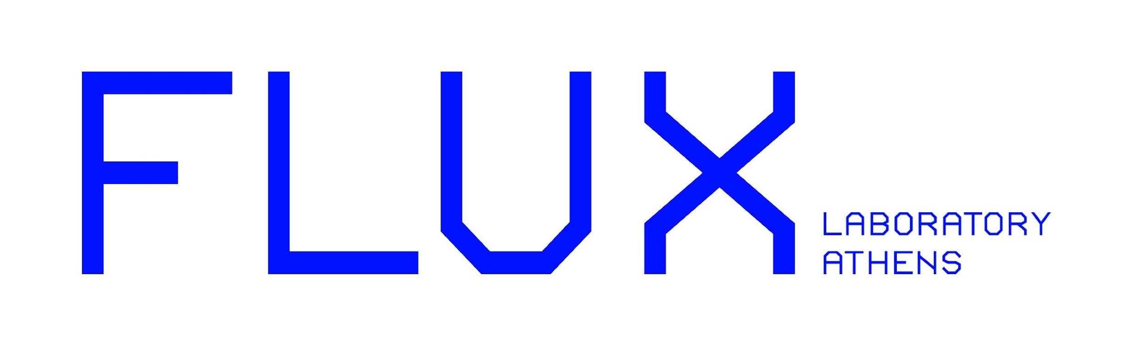
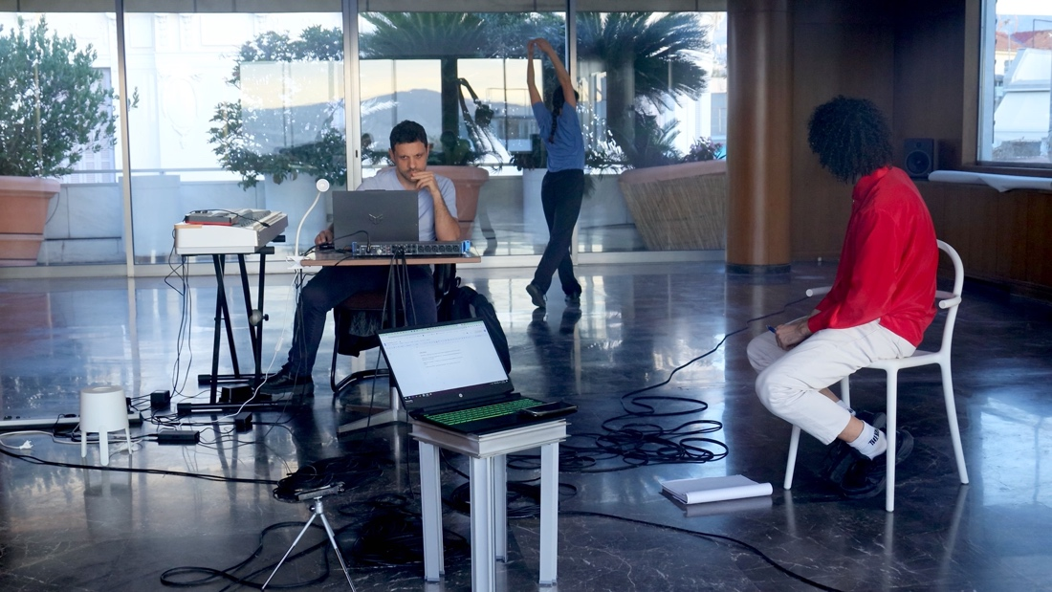
© Xenia Tsilochristou, 2023

EXPERIMENT B: Results of the artistic residency
22, 23, 24 January 2024, 19:00
Building at 5 Palaiologou Mpenizelou , 105 56
4th floor

The cycle of artistic residencies titled Experiment started in September 2022 as an inter-disciplinary artistic residency initiative for choreographers and researchers-scientists. Its purpose is to explore the creative collaboration between artistic practice and scientific research through a process-based experience. This synergy between science and dance is based on exchange, dialogue, inspiration and co-creation, while being developed on the fringes of the respective disciplines.

In its second edition – Experiment B – Flux Laboratory Athens invited through an open call, existing collaborative duos or groups that involve at least one choreographer and one scientist to apply with an idea or project that they wished to collaborate on. This year’s selection panel members were: Kyriaki Nasioula (choreographer, Experiment A artist), Maria Karoglou (chemical engineer, NTUA, Experiment A scientist), Christiana Kazakou (transdisciplinary curator & producer, Experiment A mentor), Andreas Kazantzidis (Professor, Department of Physics, University of Patras), Olga Ktenidou (Seismologist, National Observatory of Athens), Niki Xenou (arts & culture manager), Georgia Tegou (choreographer).

The residents of Experiment B, Angelos Papadopoulos (choreographer), Konstantinos Bakogiannis (sound and music computing post-doc researcher, department of Music Studies, University of Athens) and Pagona Boulmpasakou (performer) have been researching sound and spatial design, interactive systems and immersive environments through their joint toolkit. Since the middle of October 2023, they have taken over the 4th floor of Paleologou Benizelou building to set up their workspace. Thus far, they have already shared their research developed through this process with students at the Department of Performing and Digital Arts (University of Peloponnese) and Moragemou Professional Dance School. The journey of the group is being followed by videographer Xenia Tsilochristou, who has been capturing the collaborative process in order to create a short documentary film.

A site specific, final presentation of their research will take place on 22, 23 and 24th January 2024, on the 4th floor of the Paleologou Benizelou building.

Residency team: Konstantinos Bakogiannis (sound & music computing researcher), Angelos Papadopoulos (choreographer), Pagona Boulbasakou (performer)
Filming: Xenia Tsilochristou
Program curator: Chloe Aligianni
Production: Flux Laboratory Athens

Performance duration: 45’

The admission is free. Online reservation is required here as limited places are available per performance.

Biographies

Konstantinos Bakogiannis
Konstantinos Bakogiannis is an engineer, musicologist, musician, and sound and music computing researcher. He holds a Ph.D. and an M.Eng. from the School of Electrical and Computer Engineering at the National and Technical University of Athens (NTUA) as well as an M.A. from the Department of Music Studies at the National and Kapodistrian University of Athens (NKUA). Currently, he is a Research Fellow at the Department of Music Studies (NKUA), having previously served as a research fellow at the Department of Informatics and Telecommunications (NKUA) and as a fixed-term Lecturer at the Department of Digital Arts and Cinema (NKUA). He is classically trained in piano performance, classical music theory, and composition (tonal harmony and counterpoint), and has also composed music for contemporary dance performances and served as a piano accompanist for ballet classes. He is currently exploring new avenues in modern piano and improvisation, as well as developing systems for music and dance interaction. His research interests are diverse, ranging from the physical modeling of musical instruments, 3D audio, spatial music, and immersive sound, to computer music, interactive multimedia, and music for contemporary dance.

Angelos Papadopoulos
Angelos Papadopoulos (he/him, they/them) is a choreographer, director and performer. Angelos’ choreographic and other related digital and performance work look to create impactful experiences for audiences where the body is foregrounded as a key site of social, political, and aesthetic ideas. The term body includes the conscious and emotional aspect and function of it. Influenced by the cultural milieu of Athens, his work explores intricate layers of self-hood in the context of cultural background, intimacy, sexuality, and personal displacement. By utilizing dance, texts, along with elements of performance and digital material, personal narrative and storytelling, his practice aims to observe and scrutinize each different project he is engaged with. His works, performed or in the form of short films or installations, have been presented at cultural institutions and platforms such as the Stavros Niarchos Foundation Cultural Centre, Tanzahoi International Dance & Dance Film Festival (Audience Award) and the Act International Festival (Guggenheim Museum Βilbao, Residency Award). He studied Economics at the Athens University of Economics & Business, Dance at the State School of Dance and the Greek National Opera Dance School. In September 2022, he graduated with honors from MRes Choreography & Performance, University of Roehampton (London), where he was awarded an alumni referral scholarship. Additionally, he was awarded Stavros Niarchos Foundation Artworks Fellowship (2020-21) and Stegi Onassis Cultural Center Fellowship to attend ‘Camping Festival’ at the Centre National De La Danse (Paris, 2021).

Pagona Boulbasakou
Pagona Boulbasakou (born in 1995) is a dancer based in Athens. She graduated from the National School of Dance in Athens (KSOT) in 2018 and is currently studying at the Department of Mathematics of the University of Patras. As a dancer, she has worked with choreographers and directors Christos Papadopoulos, Mariela Nestora, Sofia Mavragani, Thanos Papakonstantinou, Dimitris Mytilinaios, Angelos Papadopoulos and Aria Boumpaki, among others. She has performed in theaters and festivals both in Greece and abroad, including: Athens & Epidaurus Festival, Brest’s national dance scene Le Quartz – Scene Nationale de Brest, Norway’s national contemporary dance stage Dansens Hus in Oslo, Tanztheater International Hannover festival, Greek National Opera, Athens Concert Hall, etc. In 2019, she participated as facilitator/dance educator in the projects “Youth Exchange I” “Youth Exchange II”, working with young people with intellectual disabilities in Poggio Mirteto, Italy (Erasmus+ program). She has also attended dance and theatre workshops and seminars with Meg Stuart, Bonnie Bainbridge Cohen, Julyen Hamilton, Bijoux de Kant and Euripides Laskaridis, among others. She has also been awarded the Stavros Niarchos Foundation Artist Fellowship by ARTWORKS in 2022.

Xenia Tsilochristou
Xenia Tsilochristou was born in Volos and studied Cinema & Television directing in Athens. She is a director, director of photography and editor. She has collaborated with production companies both in the field of advertising, cinema as well as theater. Among others, she has directed the documentaries "A hug for the Third e-age", "Before Now After", "Lend An Ear". From 2022 collaborates with the Greek Art Theater Karolos Koun and creates the trailers of its theatrical productions. She has worked at Star Channel (B. Director Program 2011), has directed video clips of well-known artists and has many years of experience in the field of documentation. She works with well-known sites on advertising campaigns and interviews (marieclaire.gr, travel.gr etc.). Her works have been awarded the Nikos Koundouros prize at the international documentary festival of Ierapetra and at other festivals with Best Direction Award, Funniest Movie Award, Best Documentary Short Film, Best Social Awareness Short Film, Best Documentary Short Film for Humanity and Audience Award.

Acknowledgements
We would like to thank Katerina El Raheb, Assistant Professor at the Department of Performing and Digital Arts (University of Peloponnese), and Aliki Kazouri, Director of Moragemou Professional Dance, for their crucial support in facilitating the workshops within their respective institutes. Our gratitude also goes to the participating students. Additionally, we would like to thank Emmanouela Soldatou for her insightful comments.

About Flux Laboratory Athens
Founded in 2003, Flux Laboratory is an experimentation laboratory originally based in Geneva, working closely with Fluxum Foundation. Flux Laboratory produces transdisciplinary artistic projects and experiments with new creative and collaborative processes. Flux Laboratory encourages synergies and since 2016, it supports and produces cultural projects in Athens under the auspices of the Embassy of Switzerland in Greece. As a hub dedicated to the development of projects related to body and movement, Flux Laboratory Athens develops and fosters artistic, social and entrepreneurial initiatives.

CONTACT
+30 210 01 08 357
athens@fluxlaboratory.com
www.fluxlaboratory.com

